GARA NAZIONALE A.F.M.
2015

PROVA DI INGLESE

Istruzioni operative
Durata della prova: 90 minuti
Non è consentito l'uso del dizionario
Non è consentito completare la prova direttamente sul foglio consegnato
Materiale necessario: fogli a righe, Answer Sheet
Punteggio totale:20
10 per la comprensione del testo (20 item) - 10 per la produzione scritta
Consegna:
- elaborato in formato cartaceo in forma anonima apponendovi solo il proprio codice alfanumerico
-busta piccola sigillata contenente i propri dati ed il proprio codice alfanumerico

PART ONE
Questions 1 — 6

Read the article below about product life cycles and the questions on the opposite page.

For each question 1-6, mark one letter (A, B, C or D) on your Answer Sheet for the answer you choose.

Product Life Cycles and Sales Strategy

One of the most important concepts in sales management and marketing is that of the product life cycle. This is a historical record of the life of a product, showing the stage in its life the product has reached at a particular time. By identifying the stage that a product is in or may be heading towards, companies can formulate better marketing plans. All products have ‘lives’ in as much as they are created, sell with varying profitability over a period of time, and then become obsolete and are replaced or simply no longer produced. A product’s sales position and proﬁtability can be expected to fluctuate over time and so, at each successive stage in the product’s cycle, it is necessary to adopt different tactics.
The two main features of the product life cycle are unit sales and unit profit. The unit sales figures usually jump on introduction, as a response to heavy advertising and promotion, as customers buy the product experimentally. This is generally followed by a levelling off while it is evaluated — the length of this period depending on the use to which the product is put. Then, unit sales rise steadily through the growth phase to the maturity phase, when the product is widely accepted, and so on to saturation level. By this time, competitors will have entered the market with their own version and, from this point, the sales team will have to work even harder to win all additional sales. Eventually, the product's sales decline as better versions enter the market and competition becomes too strong.
In retrospect, most firms know what happened to their products from launch to withdrawal. They can compile this information from the records of unit sales.
Unfortunately, unit sales are not the complete story as it is unit profit that is the decisive factor, although this is not always recorded accurately. It is this figure that sales management has to monitor, though, to ensure an effective marketing strategy and to produce effective profits.
At launch, the product is costed accurately on the basis of production costs plus selling costs. Initially these remain fairly stable, but, when the product is proving successful, competitors will bring out their own ‘copy-cat’ products. With a competitor in the field, the original firm has to respond in order to maintain its market position. It can run special sales promotions, improve deliveries, make more frequent sales calls and so on. Often the extra expenditure is not accurately charged to the product and the result is that, long before unit sales are noticeably falling, the unit profit has already fallen.
The product life cycle, then, presents a picture of what happened in the product's “lifetime”, so how can this be used as an ongoing aid to management decision—making.’ Every sales manager has a chart on which the progress of sales is plotted and this can be used as a guide to the stage of development each product is currently in. An essential management skill is being able to interpret sales results and draw in the stages as they occur. Deciding where each stage begins and ends can be a random exercise, though usually the stages are based on where the rate of sales growth or decline becomes pronounced.

1 According to the text, the end of a product’s life cycle is marked by

- a sharp rise in production costs.
- the product becoming outdated.
- an increase in customer complaints.
- less support from sales management.

2 What does the writer say about sales management in the first paragraph?

- Companies should spend more time on their sales planning.
- There are many managers who need to improve their sales performance.
- Most sales managers fail to recognise which stage a product has reached.
- The sales approach should change with each phase of the product life cycle.

3 According to the text, a greater sales effort is required for a product when

- it is particularly innovative.
- the advertising budget has been cut.
- rival companies start to produce something similar.
- consumer interest switches to a new product category.

4 According to the text, a good marketing strategy must primarily be concerned with

- sales statistics.
- product details.
- consumer data.
- profit information.

5 According to the text, profit levels may fail to correspond to the volume of sales because

- the full selling costs have not been taken into account.
- the production costs were not estimated correctly.
- there are unforeseen problems with distribution.
- there has been a lack of economic stability.

6 What does the writer say about the charts that show sales progress?

- It is a matter of judgement where one sales phase finishes and another begins.
- Managers should review policy when a sharp fall in sales is indicated.
- It is difficult to see how sales charts can provide sufficient guidance to managers.
- Managers should get conﬁrmation of the data they plot on the sales charts.

PART TWO
Questions 7-20

Read the advice below about the use of technology in presentations.

Choose the best word to fill each gap from A. B, C or D on the opposite page.

For each question 7-20, mark one letter (A. B, C or D) on your Answer Sheet.

There is an example at the beginning, (0).

Guidelines for giving Presentations

Most presentations today (0)…B…. on the use of some sort of technology, such as a laptop computer linked to a projector. While this technology can help to (7) ...... presentations better, it also has a (8)…….. of getting in the way. As a general (9) ....... it is better to (10) …… on the content of a presentation as a means of (11) ...... your audience's attention, rather than relying on sophisticated equipment.

Bear in mind that when an organisation invites (12) ...... for a contract, they may (13) ...... four or ﬁve presentations from different companies on the same day. Each of these companies will probably be using the same computer graphics (14) ..... and the same equipment. The chances are the presentations will be similar too.

That's why the content and (15) ...... of what you say are important. Think about what you want to say and how to say it as clearly as possible. As a ﬁrst step, you need to (16) ...... the main points you want to get across. Audiences are easily bored and (17) ...... to remember only the most entertaining, exciting or unusual ideas.

Next create your materials, choosing the images for your presentation carefully. Remember you do not want to stop your audience from listening to you, nor do you want to (18) ...... them.

Finally, make all the necessary (19) ...... for the equipment you need. If technology is to be an important (20) ...... of your presentation, make sure you know how to use it properly and test it out beforehand.

7 A produce

8 A behaviour

9 A method

10 A focus

11 A gaining

12 A requests

13 A appoint

14 A parcels

15 A formation

16 A catalogue

17 A point

18 A disorder

19 A appointments

20 A share

B make

B habit

B law

B define

B acquiring

B calls

B programme

B packets

B design

B label

B tend

B mistake

B procedures

B role

D build

D routine

D course

D direct

D taking

D commands

D catalogue

D packages

D system

D identify

D move

D complicate

D organisations

D element

C construct

C practice

C rule

C target

C collecting

C bids

C schedule

C bundles

C structure

C mark

C lead

C confuse

C arrangements

C function

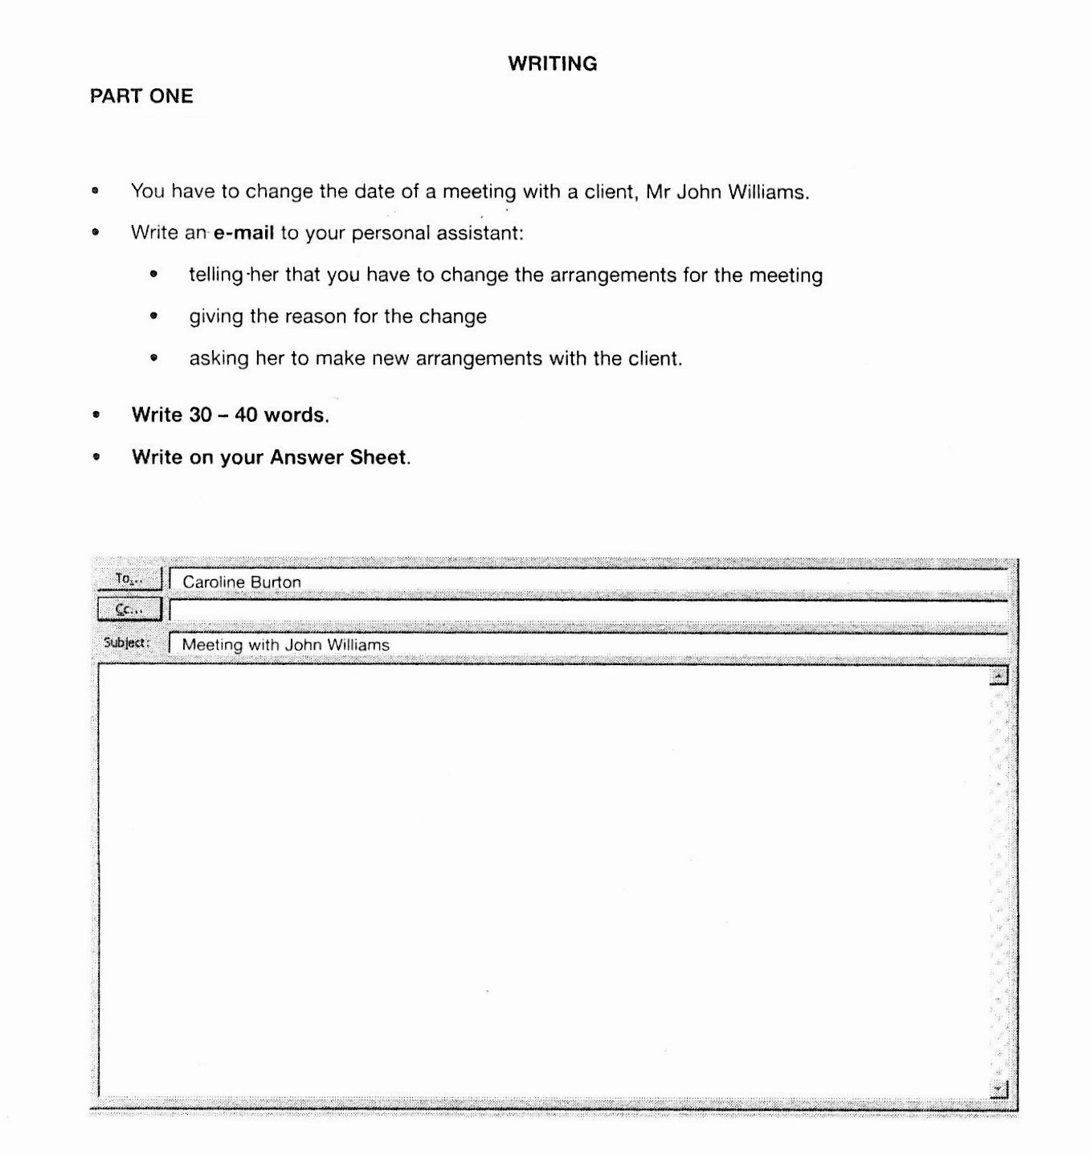

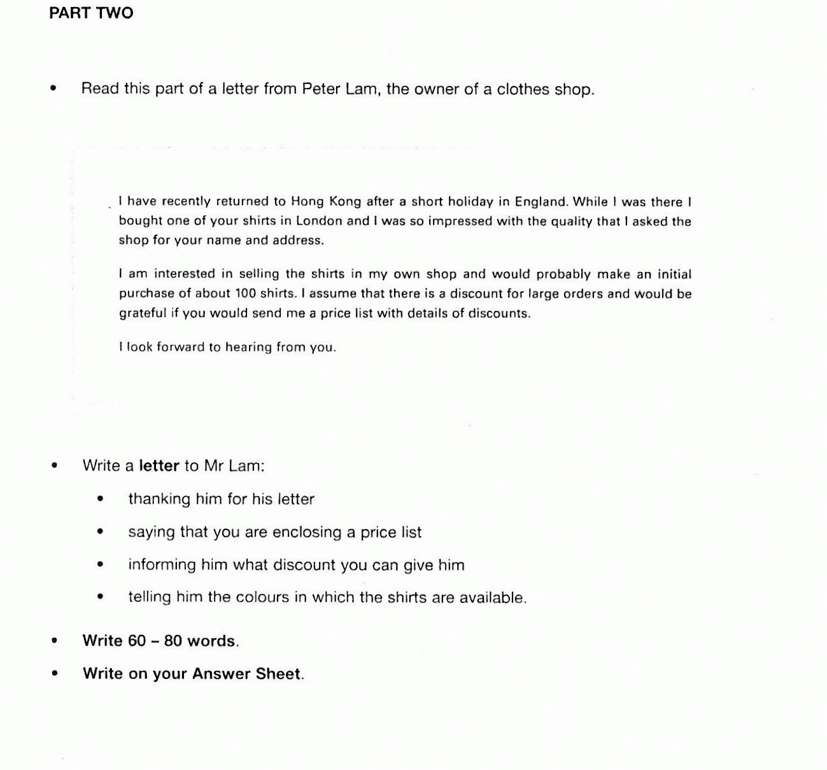

CODICE ALFANUMERICO
MARK SCHEME | marks | Writing  1 | Writing  2

Full realisation of the task set  - all content points included and expanded upon where the task allows  - controlled, natural use of language;minimal errors which are minor  - wide range of structure and vocabulary  - effectively organised,with appropriate use of cohesive devices  - register and format consistently appropriate  Very positive effect on the reader | 5
Good realisation of the task set  - all content points adequately dealt with  - generally accurate,errors when complex language is attempted  - good range of structure and vocabulary  - generally well-organised,with attention paid to cohesion  - register and format on the whole appropriate  Positive effect on the reader | 4
Reasonable achievement of the task set  - all major content points included;some minor omissions  - a number of errors will be present,but they do not impede communication  - adequate range of structure and vocabulary  - organisation and cohesion are satisfactory, on the whole  - register and format reasonable ,although not entirely successful  Satisfactory effect on the reader | 3
Inadequate attempt at the task set  - some major content points omitted,or inadequately dealt with,some irrelevance is likely  - errors sometimes obscure communication,are numerous and distract the reader  - limited range of structure and vocabulary  - content is not clearly organised or linked,causing some confusion  - inappropriate register and format  Negative effect on the reader | 2
Poor attempt at the task set  - notable content omissions and/or considerable irrelevance,possibly due to misinterpretation of the task set  - serious lack of control;frequent basic errors  - little evidence of structure and vocabulary required by task  - lack of organisation,causing a breakdown in communication  - little attempt at appropriate register and format  Very negative effect on the reader | 1

MULTIPLE CHOICE /10

PUNTEGGIO TOTALE /20

